

Safety Bay Senior High School

Year 7 Physics Investigation

Background Information

Name: ____________

Part 1 – What is Friction?

<https://www.bbc.co.uk/bitesize/topics/zsxxsbk/articles/zxqrdxs>

Read the article and answer the following questions in your own words. Make sure that your answers are in full sentence answers.

1. Define friction.

|  |
| --- |
|  |
|  |
|  |

1. In the space below Bob is pushing a box forward with a force of 200N. Draw in the friction force.

200N

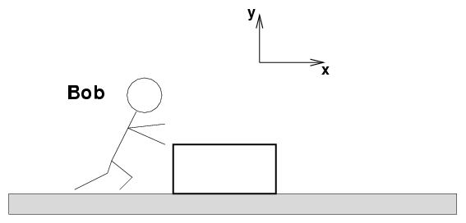

1. Using the information from Question 2 explain which force would be larger the friction or Bob’s pushing. Justify your answer.

|  |
| --- |
|  |
|  |
|  |
|  |
|  |

1. What determines how much friction will occur between two objects?

|  |
| --- |
|  |
|  |
|  |

Part 2 – Effects of friction?

Conduct research for the following questions. Make sure that you are not using the answer that comes up on google, instead go to actual websites. DO NOT USE WIKIPEDIA.

1. What surfaces are considered frictionless?

|  |
| --- |
|  |
|  |

1. When an object is on a frictionless surface would it eventually stop?

|  |
| --- |
|  |
|  |
|  |

1. Friction coefficients are determined based on the relationship between the Normal force (pushing the block against the ground) and the Frictional force. The larger the frictional force the larger the value, the more force that is required to push the block against a surface. Use the table below to order the flooring types from the largest frictional force to the smallest frictional force.

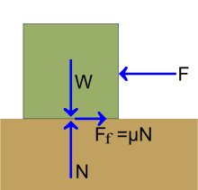

|  |  |
| --- | --- |
| Flooring Type | Friction Coefficient Range |
| Carpet | 0.0150-0.0212 |
| Rubber | 0.6 |
| Lino | 0.0013-0.0099 |
| Sandpaper | 0.061 – 0.073 |
| Floor board (Wood) | 0.25 – 0.5 |

|  |  |
| --- | --- |
| Largest frictional force |  |
|  |  |
|  |  |
|  |  |
| Weakest frictional force |  |

1. Using the information above explain which flooring would be easiest to push a 100kg box across.

|  |
| --- |
|  |
|  |
|  |

1. Why is it important for us to use friction when running? What effect what would completing a running race on ice have?

|  |
| --- |
|  |
|  |
|  |
|  |